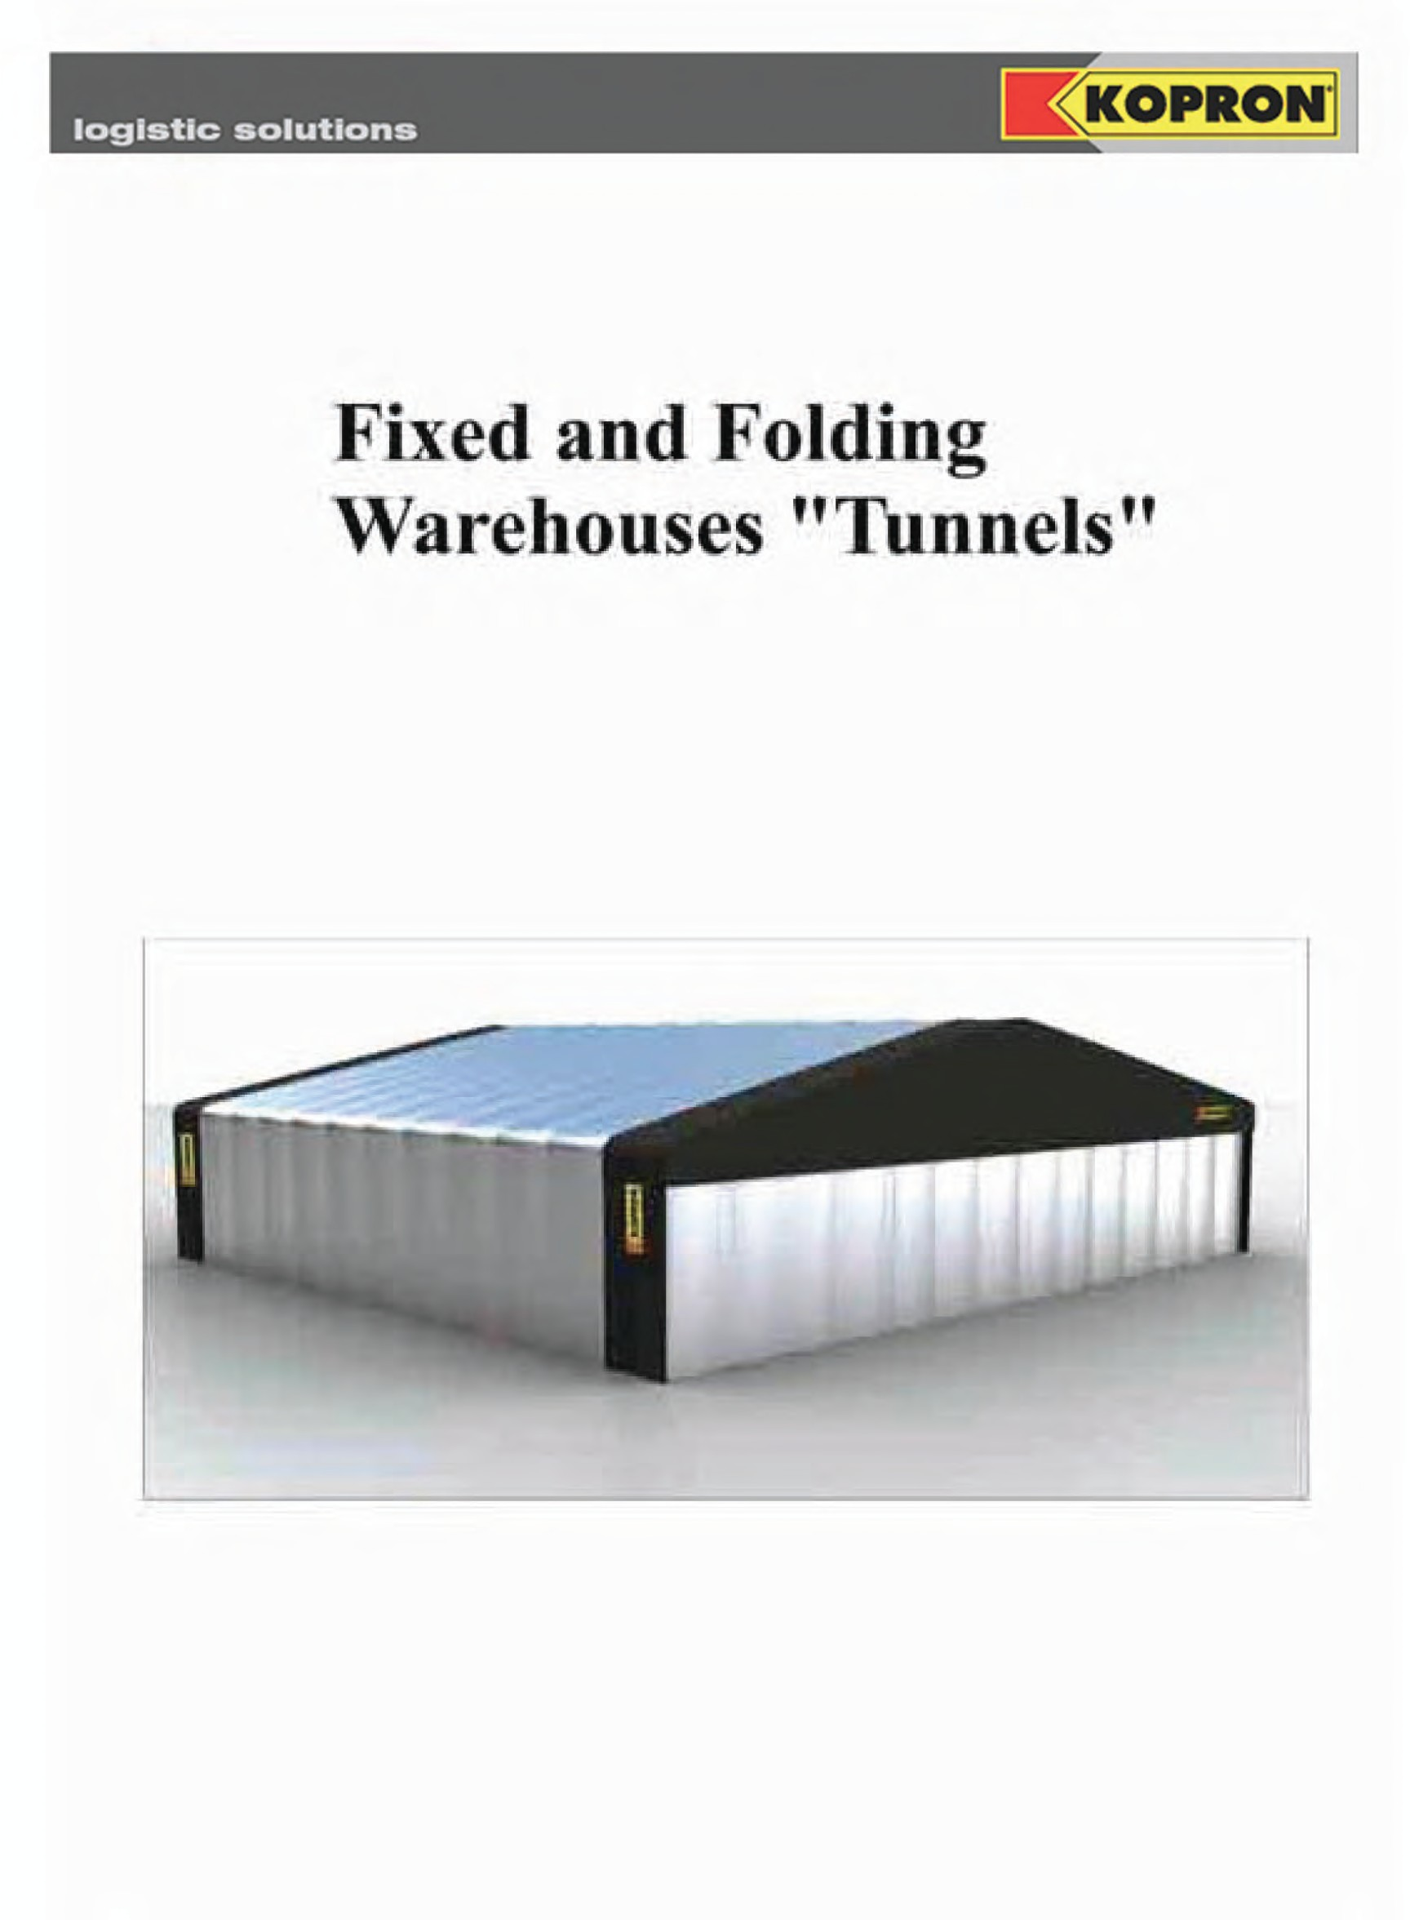

Freestanding Fixed -Mod. KTF Folding -Mod KT
Front mounted
Fixed - Mod. KTF (P) Folding - Mod. KT (P)

Side mounted
Fixed - Mod. KTZF Folding - Mod. KTZ

Double side mounted Fixed - Mod. KTTF Folding - Mod. KTT

Side mounted- sloping roof Fixed - Mod. KTZMF Folding - Mod. KTZM
Canopies
Fixed - Mod. KTTSF Folding - Mod. KTTS

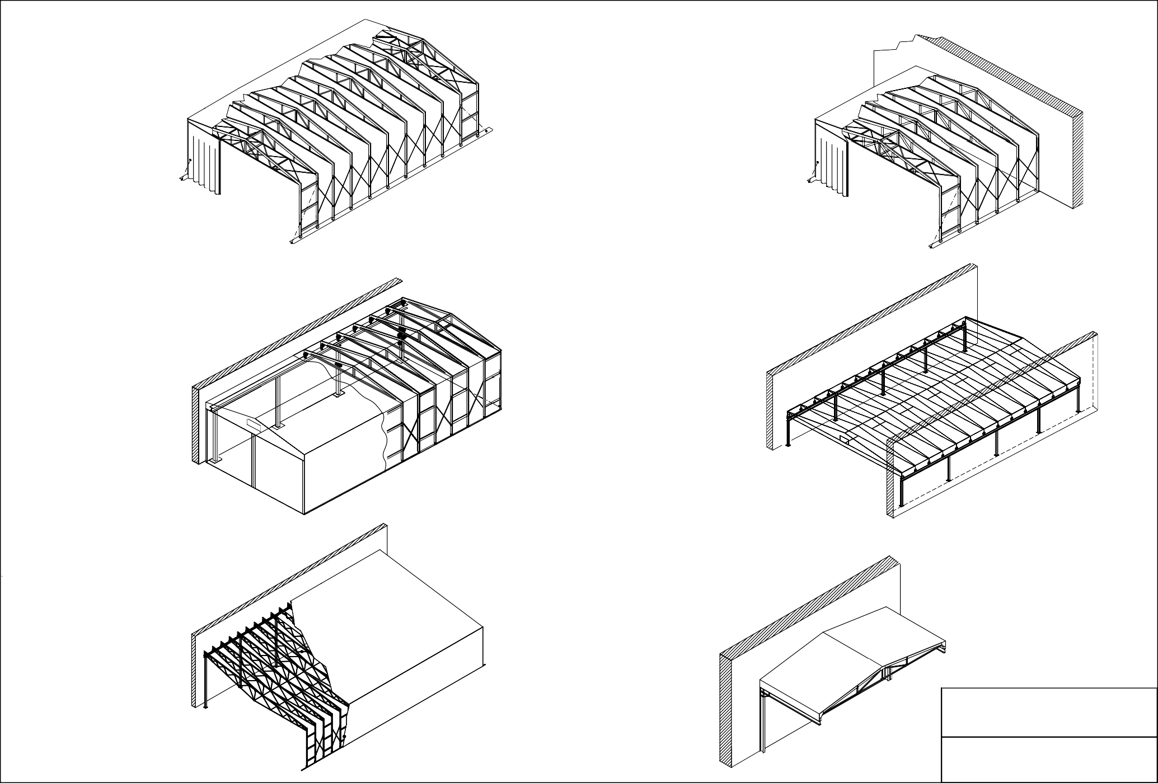

KOPRON

Re: Folding / Fixed Tunnel Possible configurations


logistic solutions

MOD. KT

Description retractable freestanding warehouse

RECTRACTABLE FREESTANDING WAREHOUSE offers a covered area either near the borders of the propriety or in open spaces like courtyards and large squares to stock and protect packed material of all kinds enabling loading/unloading operations under any weather condition.

THE CARRYING STRUCTURE consists of arcs connected to one another by pantograph bars all in galvanised steel with no need of maintenance.
Sliding is performed forged and turned steel wheels provided with double ball bearings positioned in a Kopron patent safety casing, with a device with a special profile 8mm thick, which is windproof and prevents derailment.
Sliding ground tracks are made of a pressed galvanised steel profile, 5 mm thick, and are complete with brackets or bored plates to be anchored to a layer of reinforced concrete.

COVERING consists of a PVC fabric, weighing 900 g/m², reinforced in parts mostly subject to wear and tear. It offers high resistance against atmospheric agents and guarantees very long life.

COLOURS AVAILABLE can be matched as follows: - cover WHITE, LIGHT GREY, CREAM COLOUR, GREEN or SILVER GREY with side and front bands ANTHRACITE GREY or SILVER GREY cover with side and front bands RED.

WORKING TEMPERATURE: -30°C +70°C

FIRE RETARDANT: Classe 2

RESISTENCE TO FOLDING: 100.000 folding on same spot.

FIXING OF THE PVC FABRIC ON THE STRUCTURE:
In order to avoid friction and consequently the wear out of the fabric, the joint plates of edges are rounded, this also enables a better tension of the fabric. On the longest trusses the fabric is protected from wear a tear thanks to a double layer of PVC in those points where friction is more frequent. The fabric is anchored to the steel structure by means of welded plates with double steel rings and belts with a breaking strength up to 350kgs

THE FRONTAL AND REAR HEAD are shut in the upper part with a fixed PVC cover anchored to the structure by means of a screwed-on glass-fiber reinforced plastic profile; the lower part can eventually be shut by two half curtains (opened from the center) which slide on an above track through carriages with double ball bearings. They are reinforced by means of metal vertical tubes inserted in pockets created along the curtain about every meter. At the end of the tubes there are locks which are anchored to the ground allowing or a partial opening of the curtain or block it completely. As an alternative to curtains you can choose among the different types of industrial closing systems such as PVC fast-closing doors or folding, sliding and sectional doors

WARRANTY: Ten years for the galvanised steel structure Six years for the PVC cover

CONSTRUCTION OF THE STRUCTURE : is carried out according to regulations in force

Agg. al 08/07/2009 1

Leght in extended position

Width

± 0.00
Total h.
Clear h.

500
500

Concrete stringcourses

Folded position
PVC fabric

Tracks

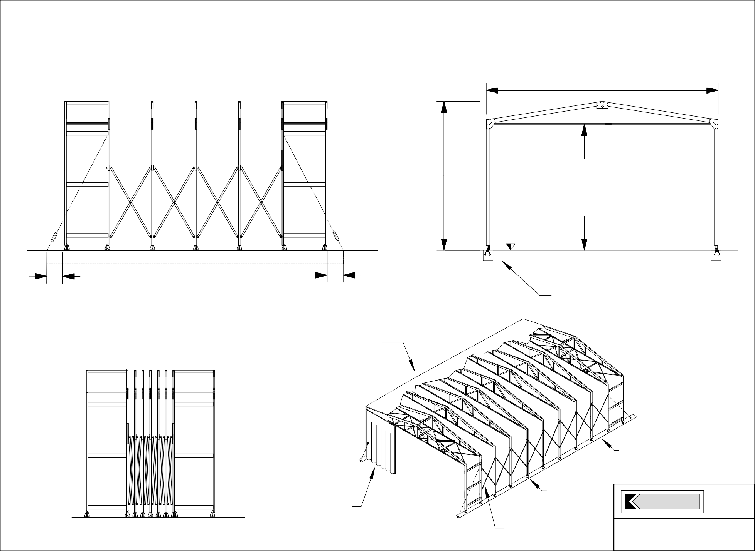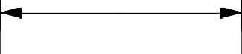
Sliding pvc curtains
Steel wheels

Pantographs

KOPRON

Re: Folding Freestanding Tunnel - Mod. KT -

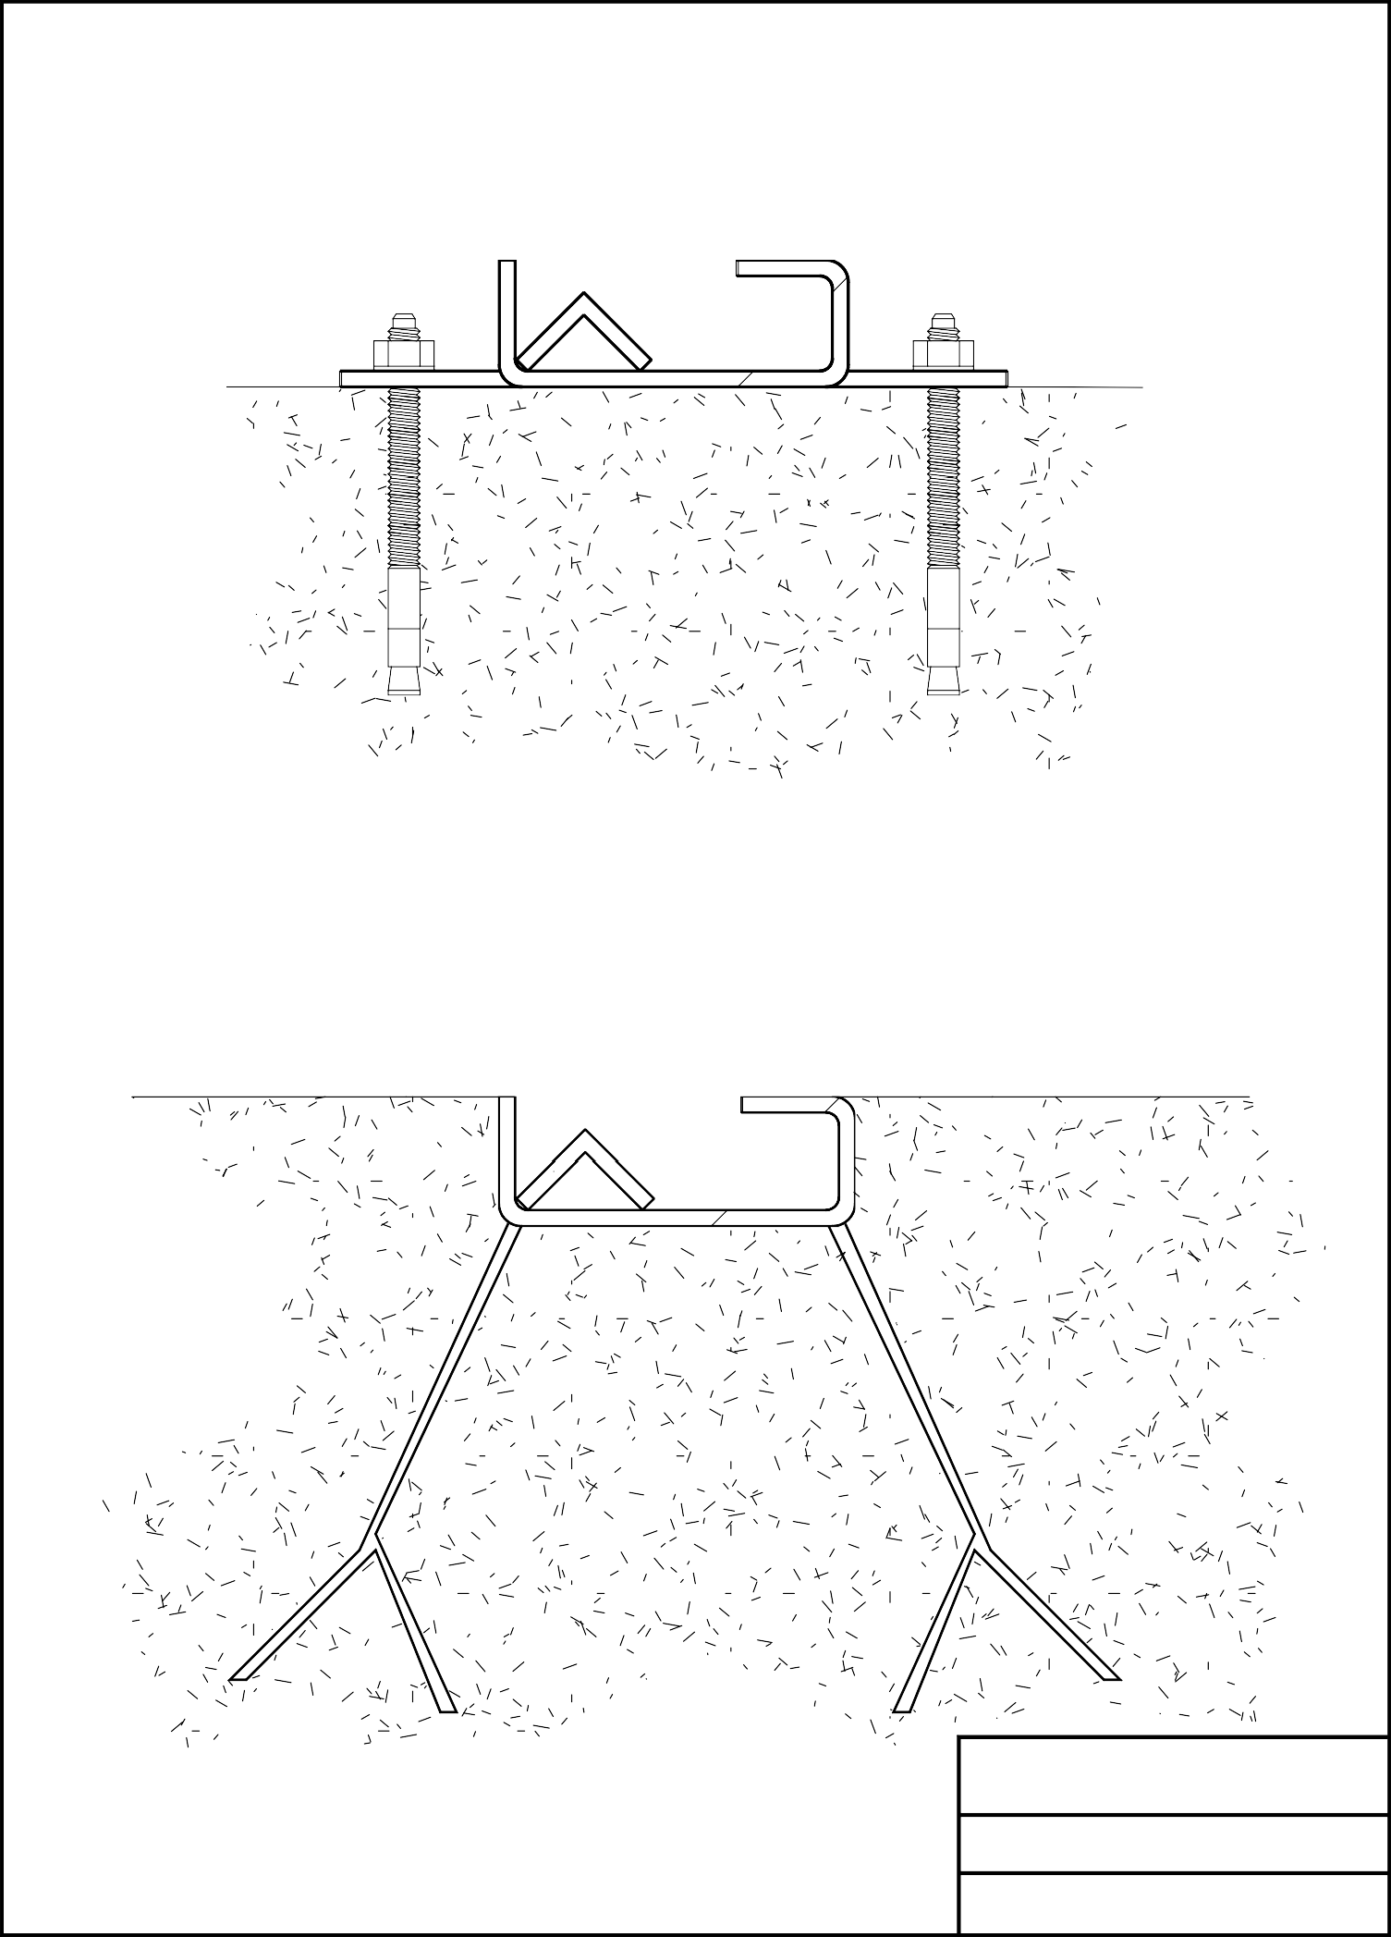Rail with anchor bolts

Rail with clamps

KOPRON

Folding warehouses
Rails possible configurations

Inside of warehouse

210

Outside warehouse

50 30 80 50

Angle 30x30x5 Plate for fixation
Rail axis

5
± 0.00
40

Concrete

Anchor bolts M10

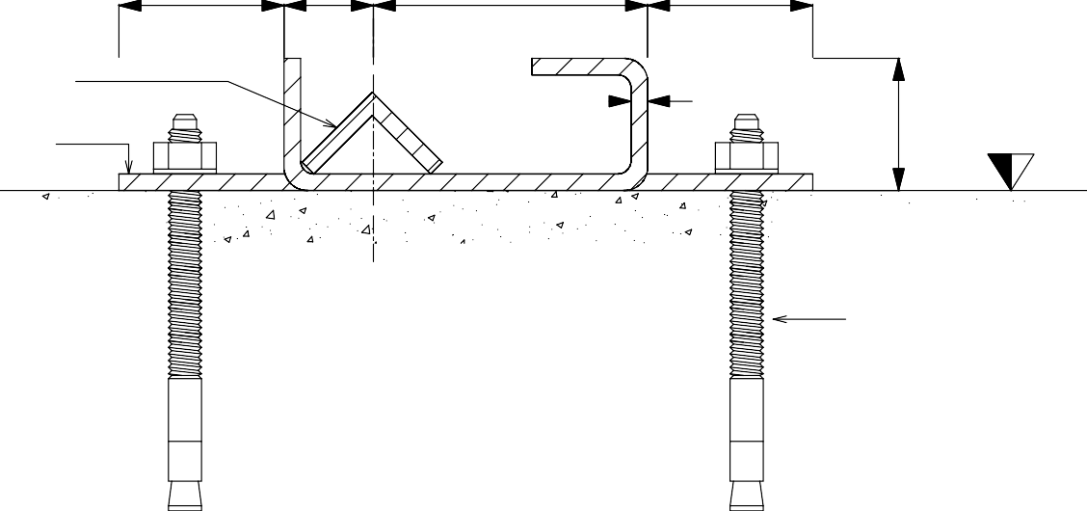

KOPRON

Folding warehouses
- Rail to be fixed by

anchor bolts -

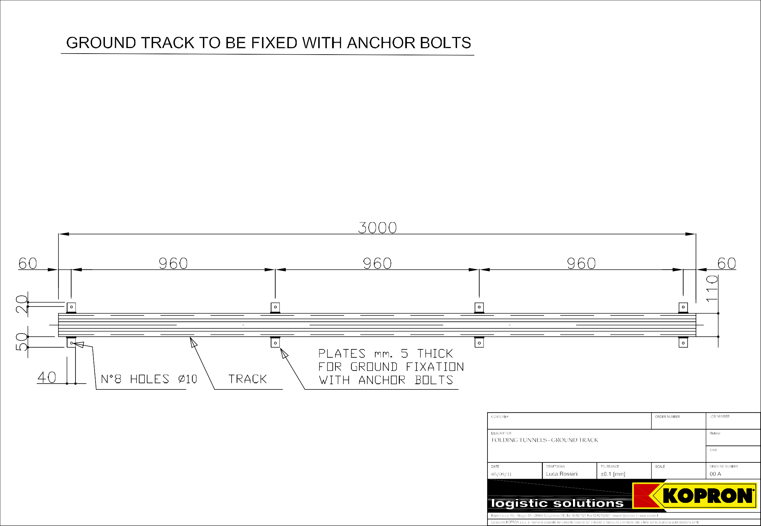

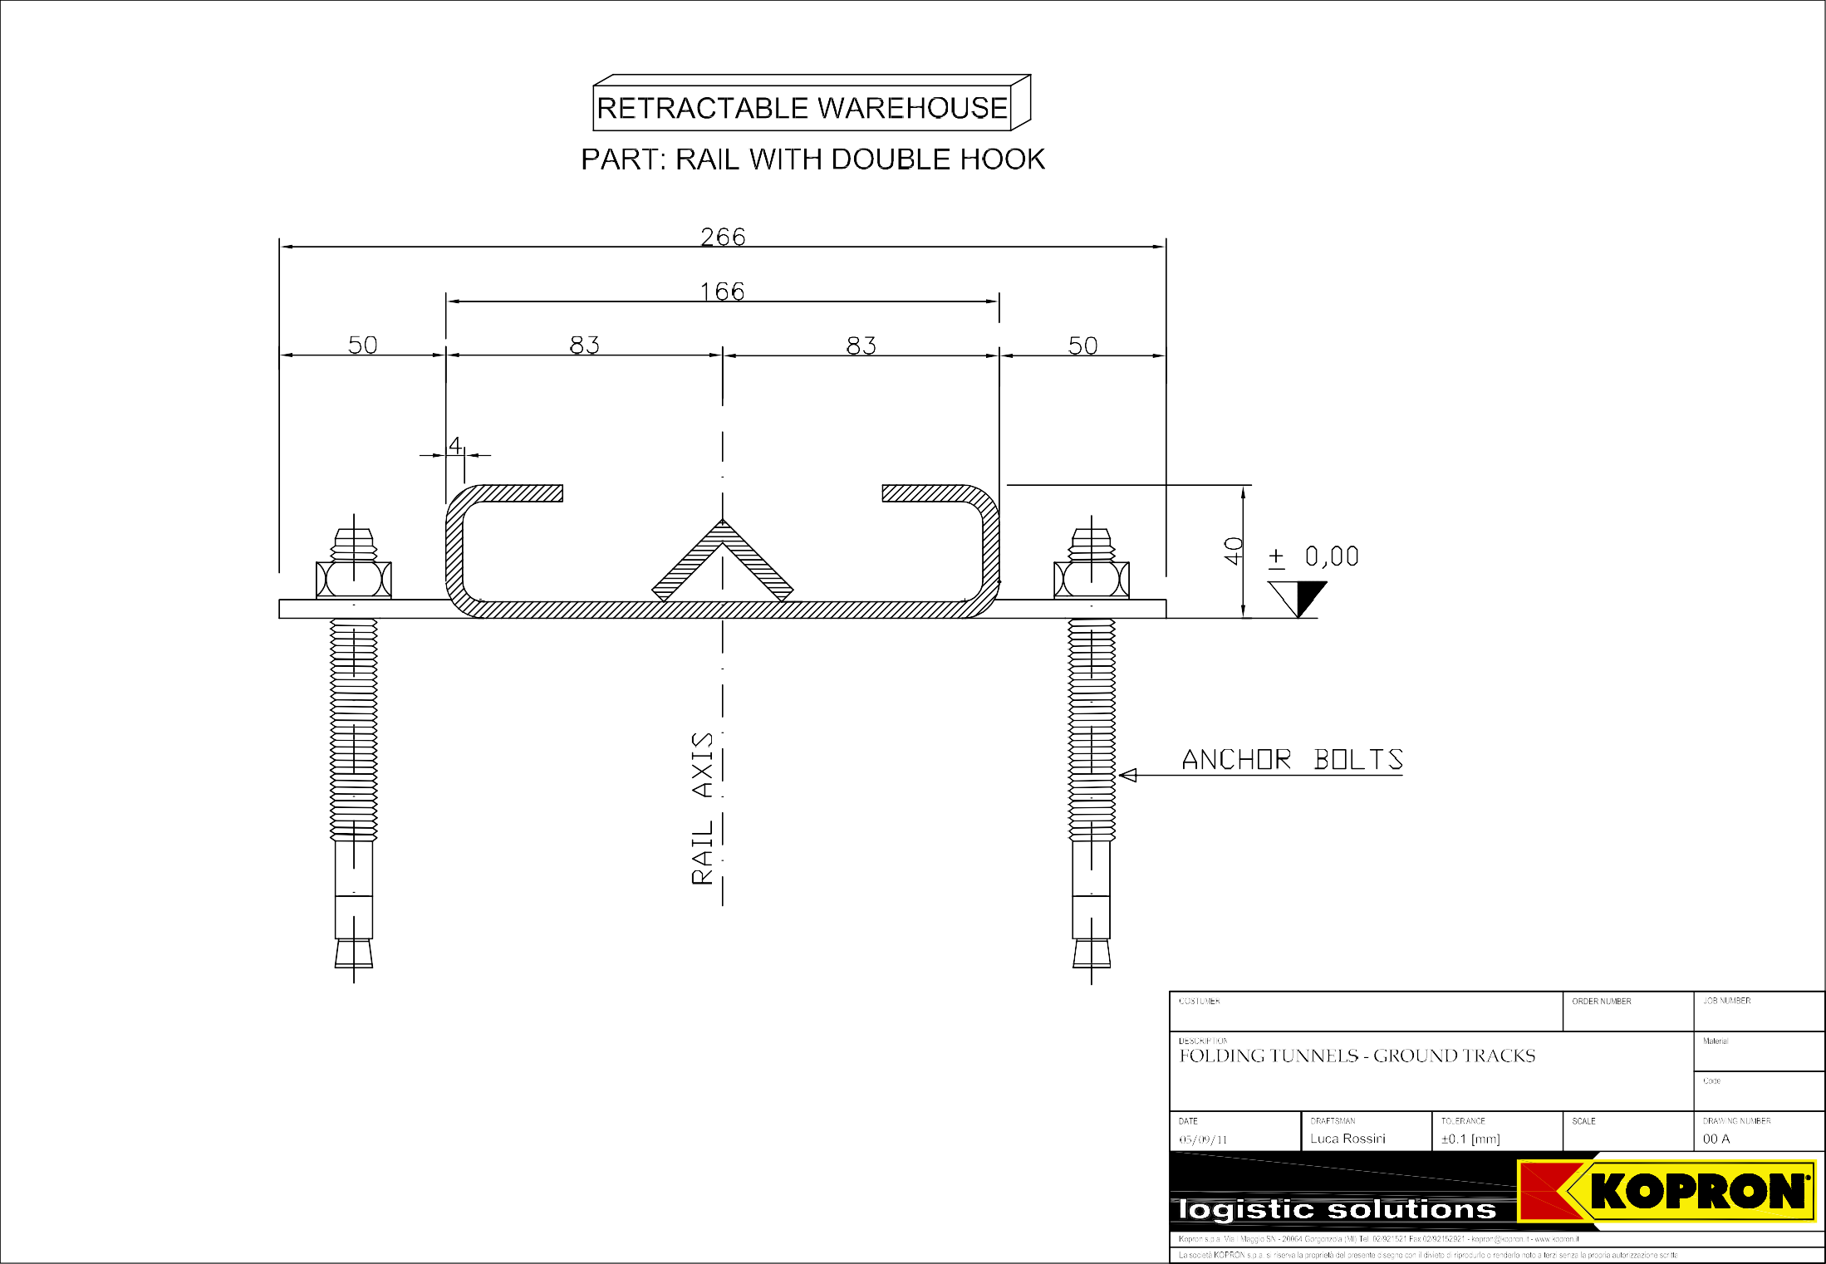

Post

Carter

Wheel
Anti-wind bracket

warehouse inside
warehouse outside

Post

Anti-wind bracket

Carter Wheel
40

± 0.00 30 80
rail
axis

Reinforced concrete stringcourse
Iron rods ø 12

Rail

Iron rods ø8 every 30 cm
600 ~

Clamps
Section

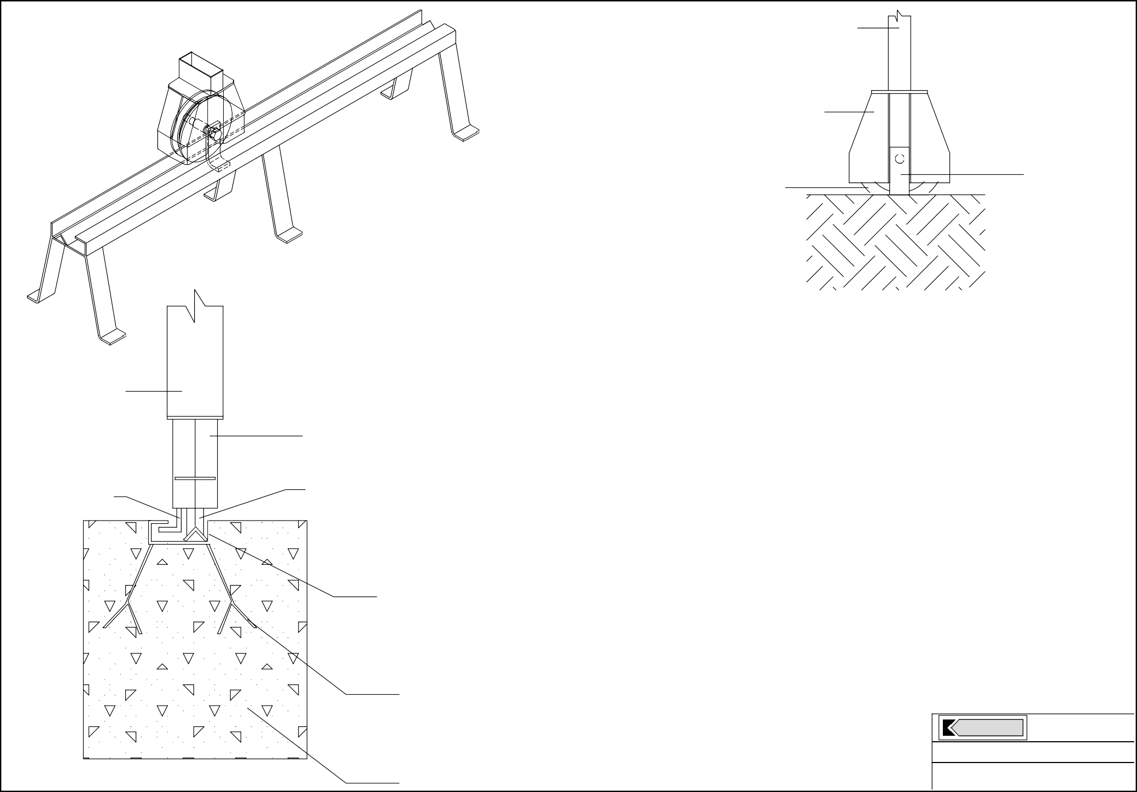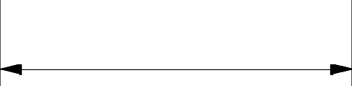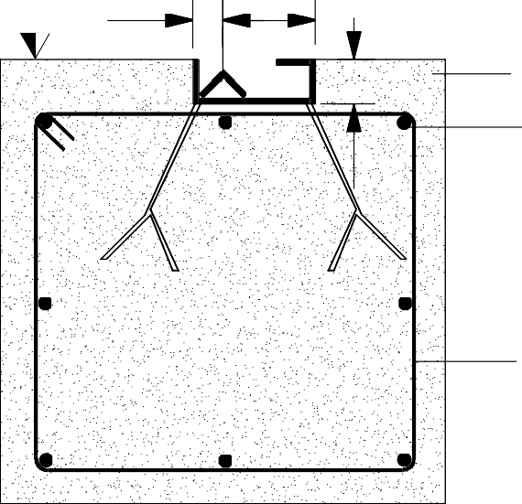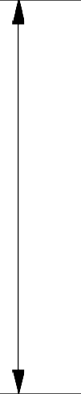
Reinforced concrete stringcourse

600 ~
KOPRON
Folding warehouses Rail with clamps

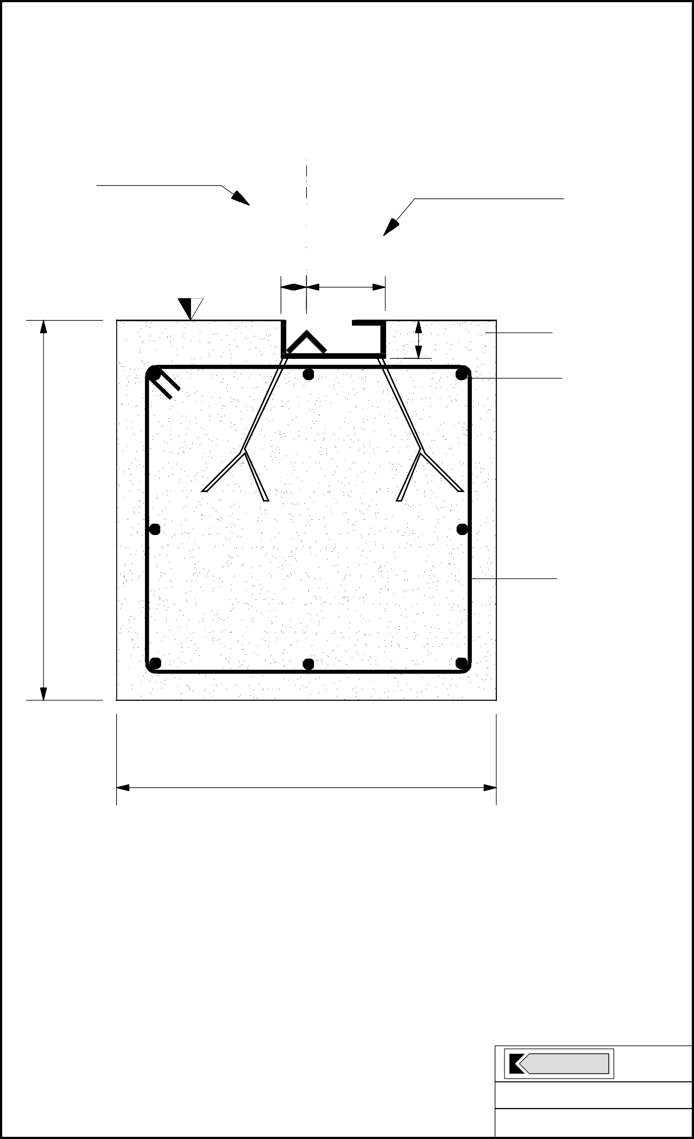

Internal side
External side
Axis
rail

± 0.00 30 80

Reinforced concrete stringcourse
40

Iron rods ø 12

Iron rods ø8 every 30 cm
600 ~

600 ~

Section

KOPRON

Folding warehouses
Stringcourse for rails with clamps

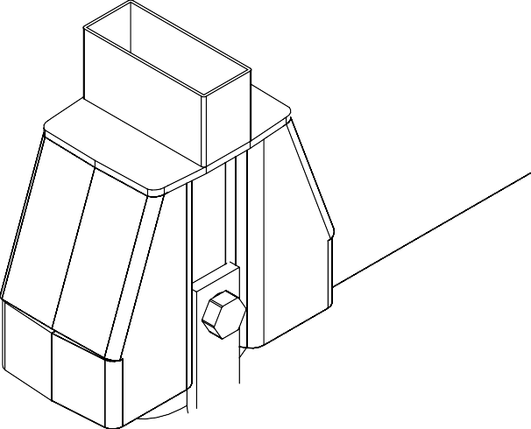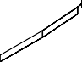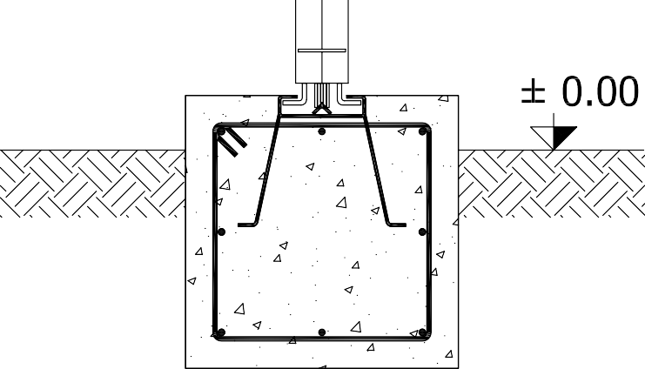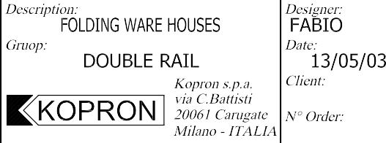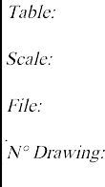

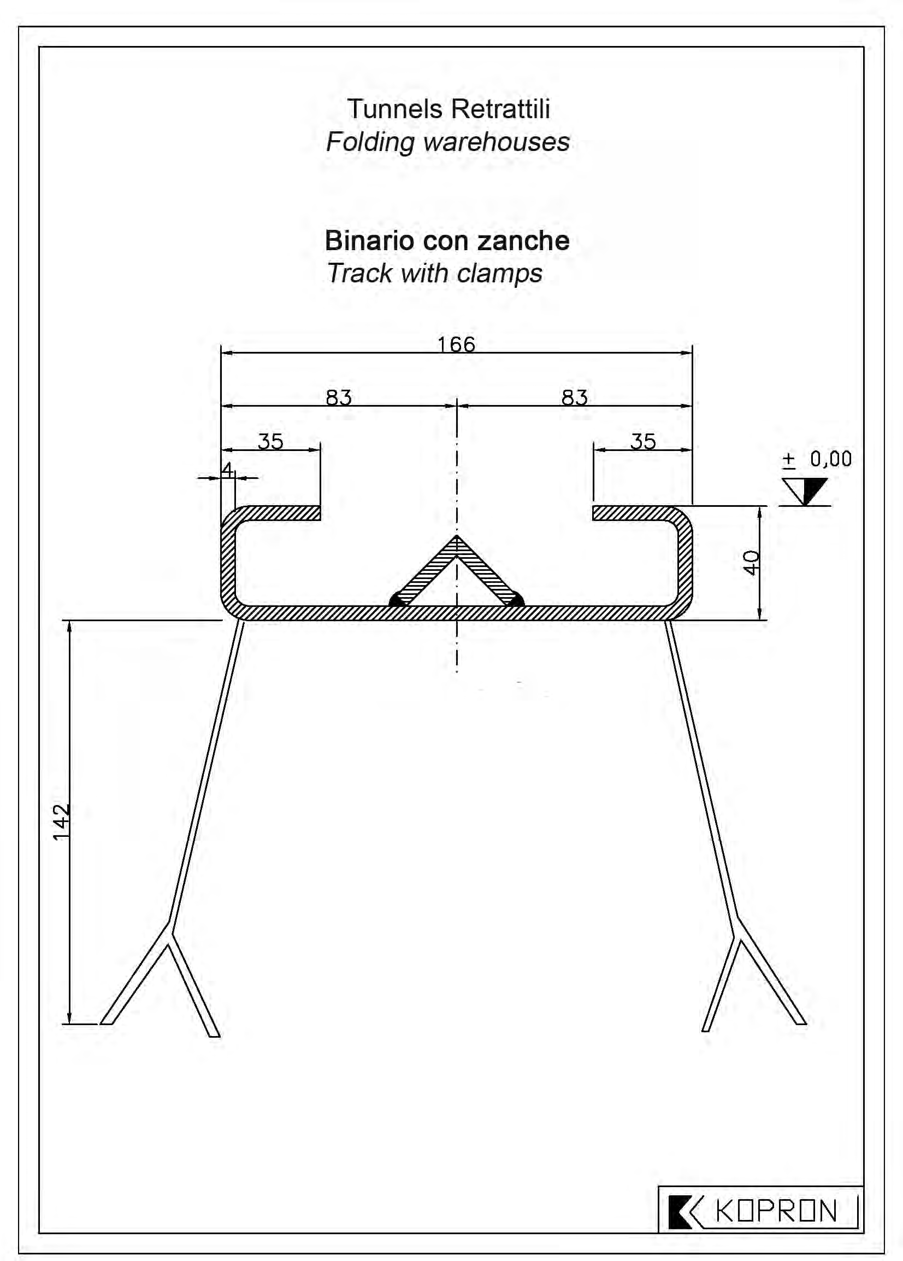

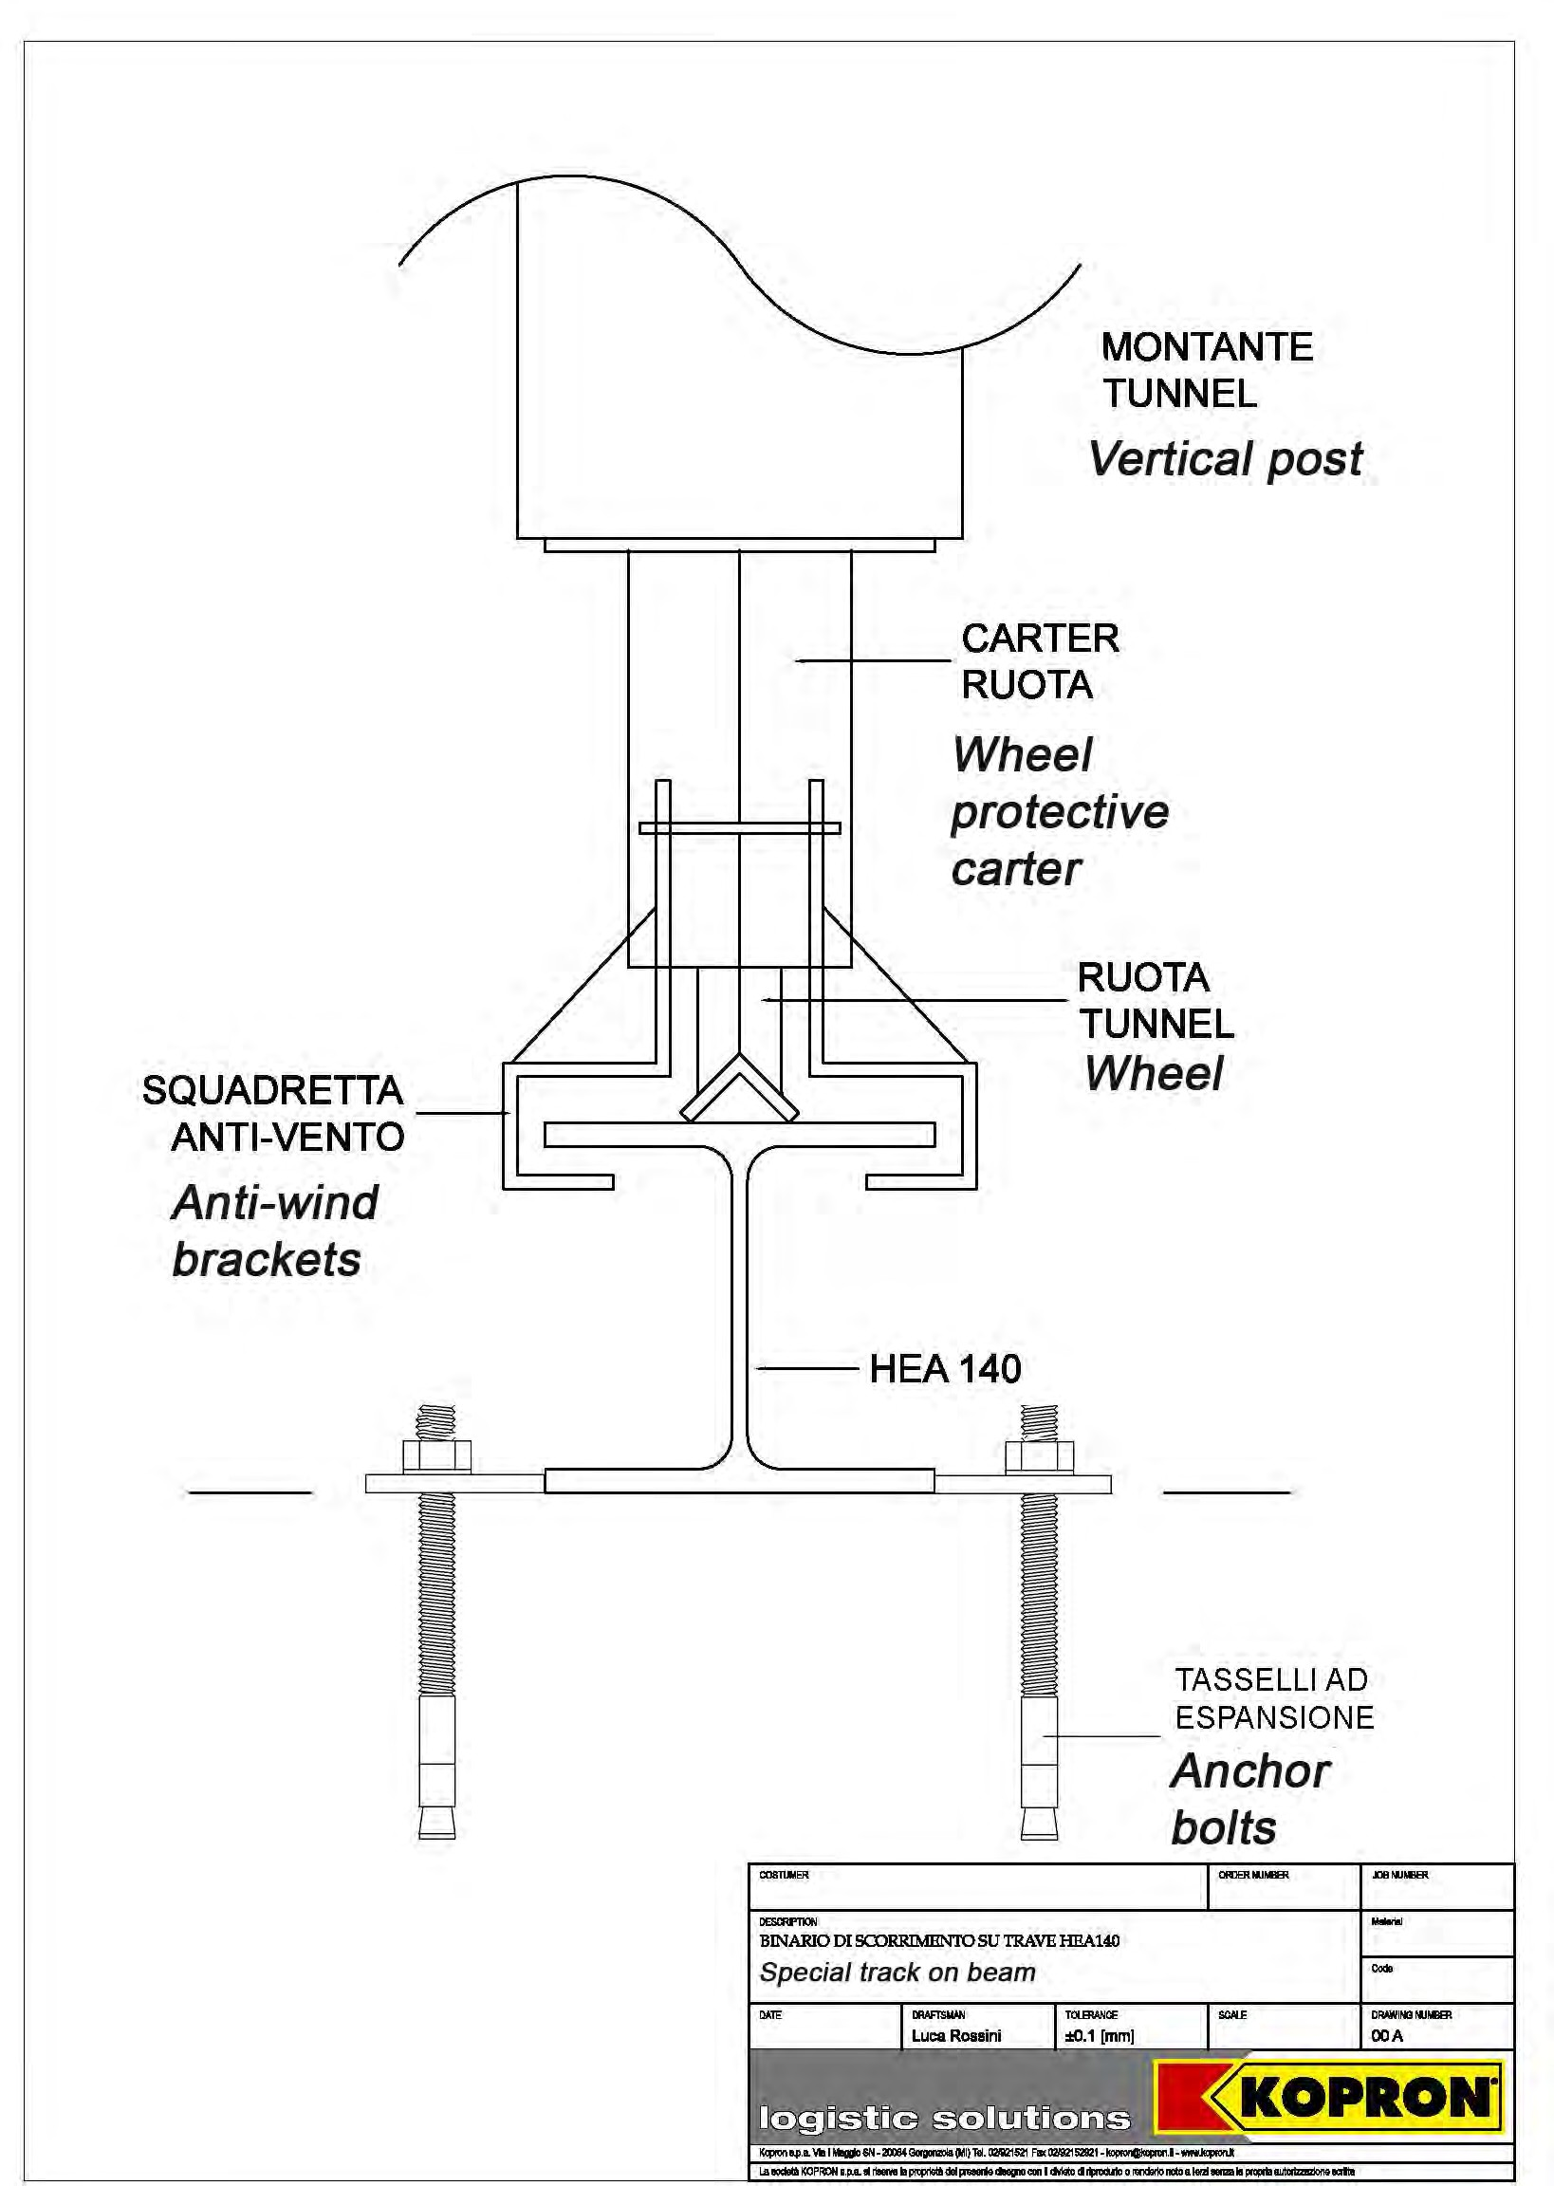

logistic solutions

MOD. KTF

Description permanent freestanding warehouse with n. 2 curtains

PERMANENT FREESTANDING WAREHOUSE WITH N. 2 CURTAINS offers a covered area
either near the borders of the propriety or in open spaces like courtyards and large squares to stock and protect packed material of all kinds enabling loading/unloading operations under any weather condition

THE CARRYING STRUCTURE consists of arcs connected to one another by spacers all in galvanised steel with no need of maintenance.
The fixing to the ground is done with flanges directly welded to the pillars doweled in a kerb in reinforced concrete

COVERING consists of a PVC fabric, weighing 900 g/m², reinforced in parts mostly subject to wear and tear. It offers high resistance against atmospheric agents and guarantees very long life

COLOURS AVAILABLE can be matched as follows: - cover WHITE, LIGHT GREY, CREAM COLOUR, GREEN or SILVER GREY with side and front bands ANTHRACITE GREY or SILVER GREY cover with side and front bands RED.

WORKING TEMPERATURE: -30°C +70°C

FIRE RETARDANT: Classe 2

RESISTENCE TO FOLDING: 100.000 folding on same spot.

FIXING OF THE PVC FABRIC ON THE STRUCTURE:
In order to avoid friction and consequently the wear out of the fabric, the joint plates of edges are rounded, this also enables a better tension of the fabric. On the longest trusses the fabric is protected from wear a tear thanks to a double layer of PVC in those points where friction is more frequent. The fabric is anchored to the steel structure by means of welded plates with double steel rings and belts with a breaking strength up to 350kgs

THE FRONTAL AND REAR HEAD are shut in the upper part with a fixed PVC cover anchored to the structure by means of a screwed-on glass-fiber reinforced plastic profile; the lower part can eventually be shut by two half curtains (opened from the center) which slide on an above track through carriages with double ball bearings. They are reinforced by means of metal vertical tubes inserted in pockets created along the curtain about every meter. At the end of the tubes there are locks which are anchored to the ground allowing or a partial opening of the curtain or to block it completely. As an alternative to curtains you can choose among the different types of industrial closing systems such as PVC fast-closing doors or folding, sliding and sectional doors

WARRANTY: Ten years for the galvanised steel structure Six years for the PVC cover

CONSTRUCTION OF THE STRUCTURE : is carried out according to regulations in force

Agg. al 08/07/2009 1

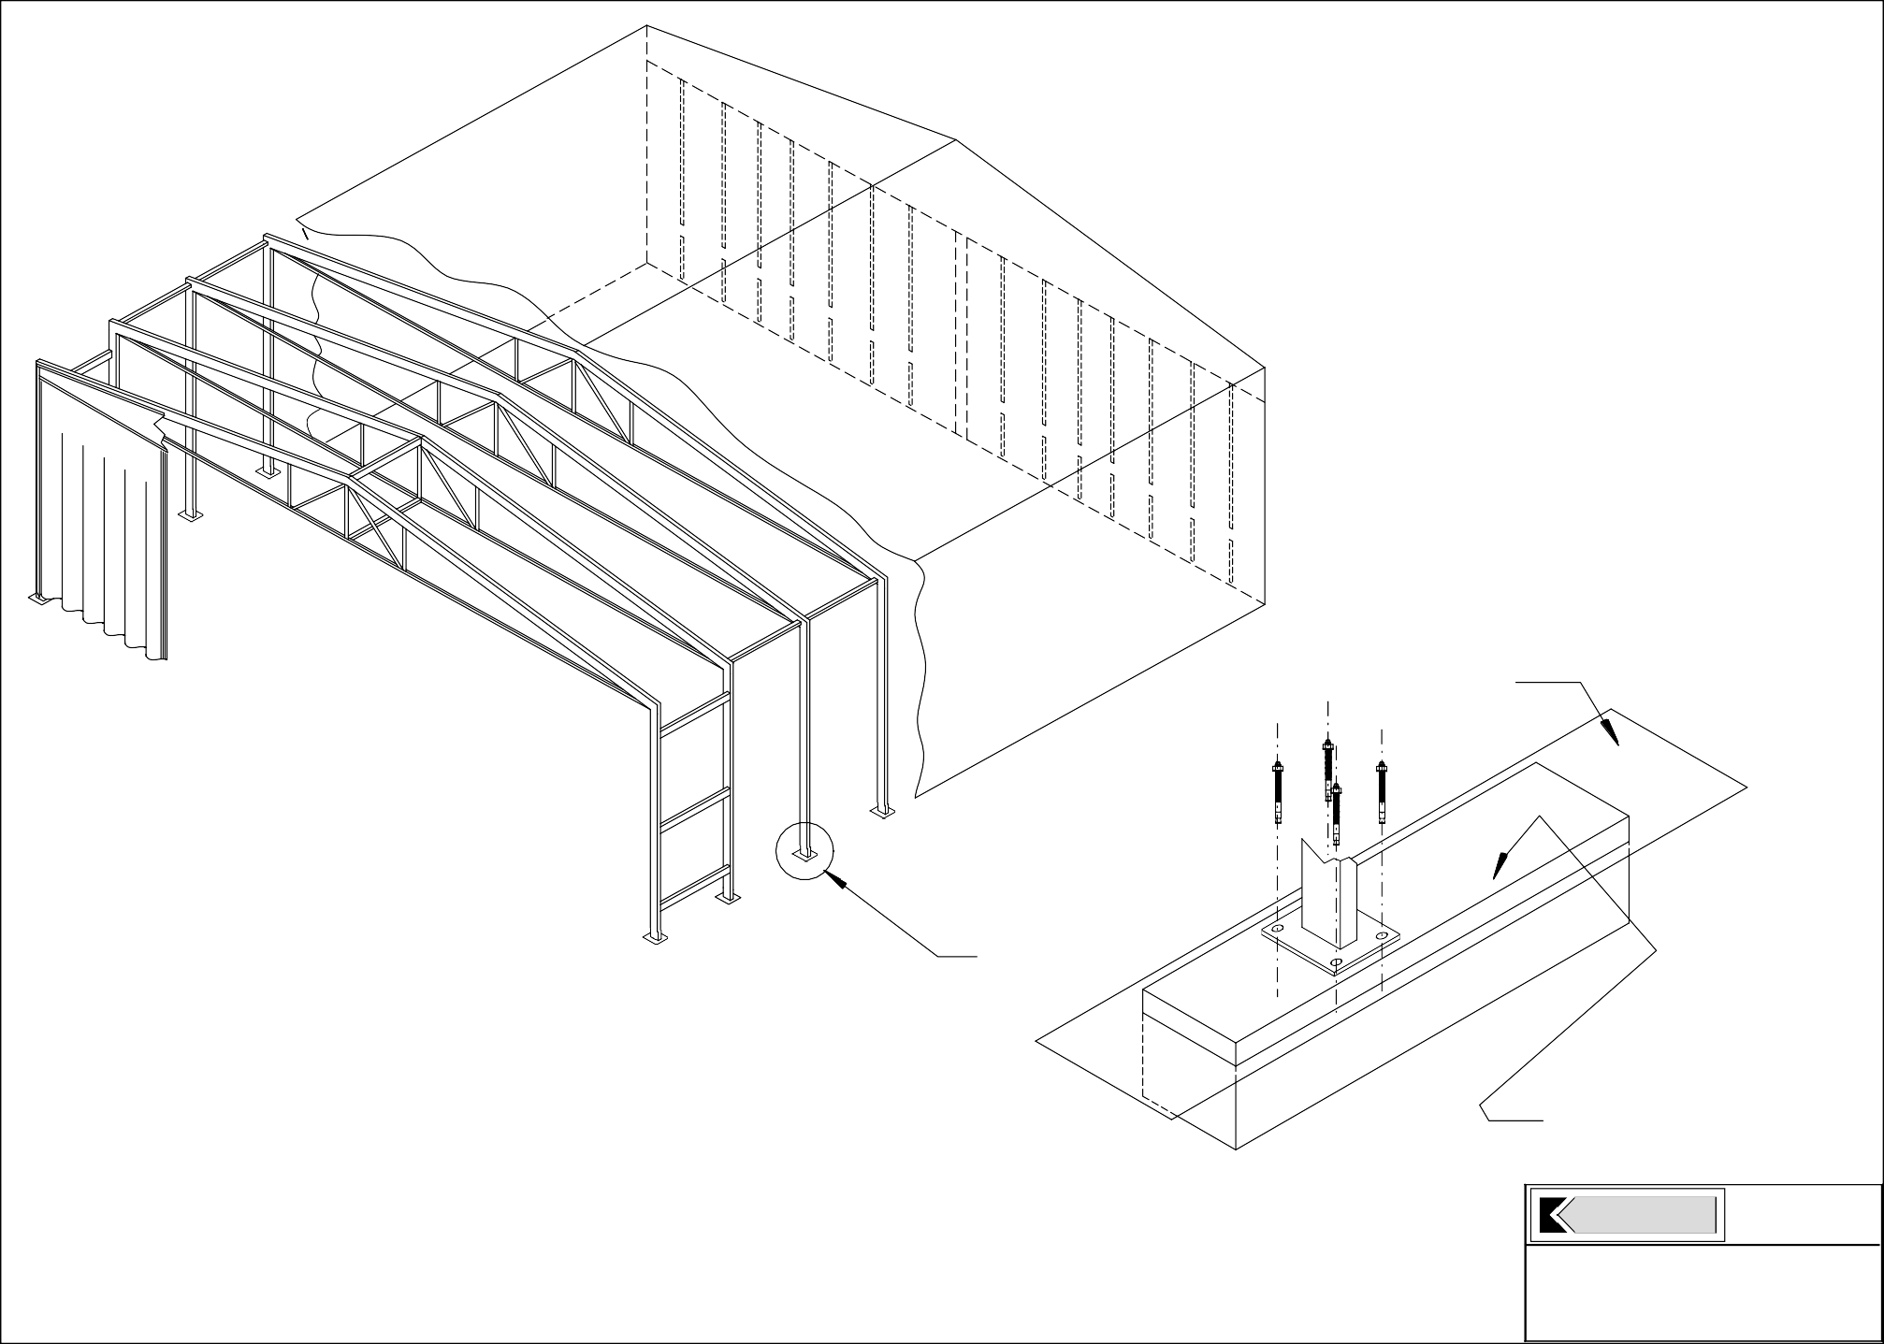

Ground level

Concrete stringcourse

KOPRON
Re: Fixed Freestanding Tunnel
- Mod. KTF -
ground posts fixation


logistic solutions

MOD. A/CURTAIN/

Description opening curtain

THE KOPRON OPENING CURTAIN enables a quick shutting of any place even of big size such as roofs either in metal, reinforced concrete or masonry, structures for agriculture and airports, etc..; it creates protected areas from weather conditions or rooms near production and stocking areas.
It consists of two half curtains (opened from the center) which slide on an above track through carriages with double ball bearings. They are reinforced by means of metal vertical tubes inserted in pockets created along the curtain about every meter. At the end of the tubes there are locks which are anchored to the ground allowing or a partial opening of the curtain or block it completely.

COLOURS AVAILABLE WHITE, LIGHT GREY, CREAM COLOUR, GREEN or SILVER GREY

WORKING TEMPERATURE: -30°C +70°C

FIRE RETARDANT: Classe 2

RESISTENCE TO FOLDING: 100.000 folding on same spot.

Agg. al 13/07/2009 1

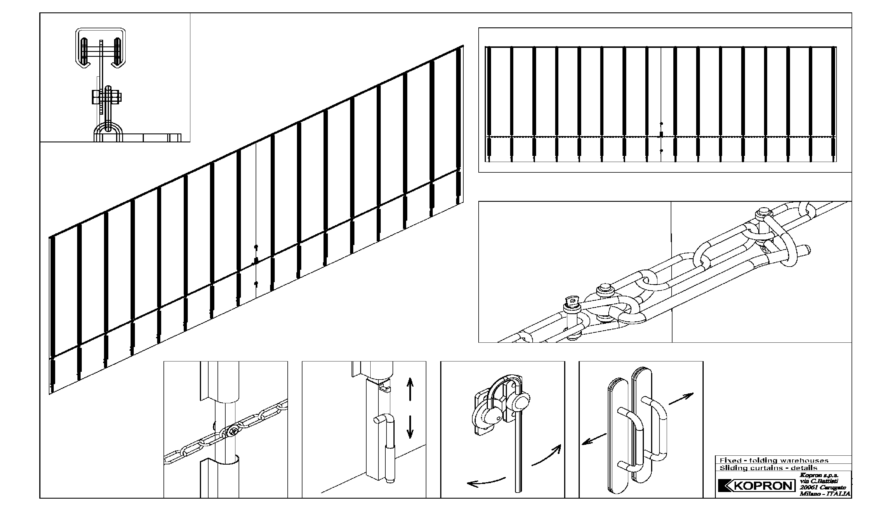



FIXED – FOLDING WAREHOUSES

Main optionals:

- Sliding PVC curtains
- Different kind of doors
- Pedestrian security door
- Motorisation
- Transparent sectors
- Double roof
- Ventilation holes
- Roof in anti-dampness pvc
- Colours assy
- Company logo

PVC FABRIC - Data sheet

PRODUCT
H-8510
BASE FABRIC |  | DIN 60001 | PES
YARN | dtex | DIN 53830 | 1100
WEAVE |  | DIN 61101 | cloth 1/1
TYPE OF COATING |  |  | PVC
TOTAL WEIGHT | g/m² | DIN 53352 | 750
TENSILE STRENGHT | warp/weft N/50 mm | DIN 53354 | 3000/2800
TEAR STRENGTH | warp / weft N | DIN 53363 | 300/300
ADHESION | N/cm | Complan norms | 20
COLD RESISTANCE | °C | DIN 53361 | -25
HEAT RESISTANCE | °C | Complan norms | 70
LIGHT-FASTNESS |  | DIN 54004 | > 6
FLAME RETARDANCY |  |  | Cl. II, DIN 4102 B1, M2
FINISH |  |  | fungicide treatment

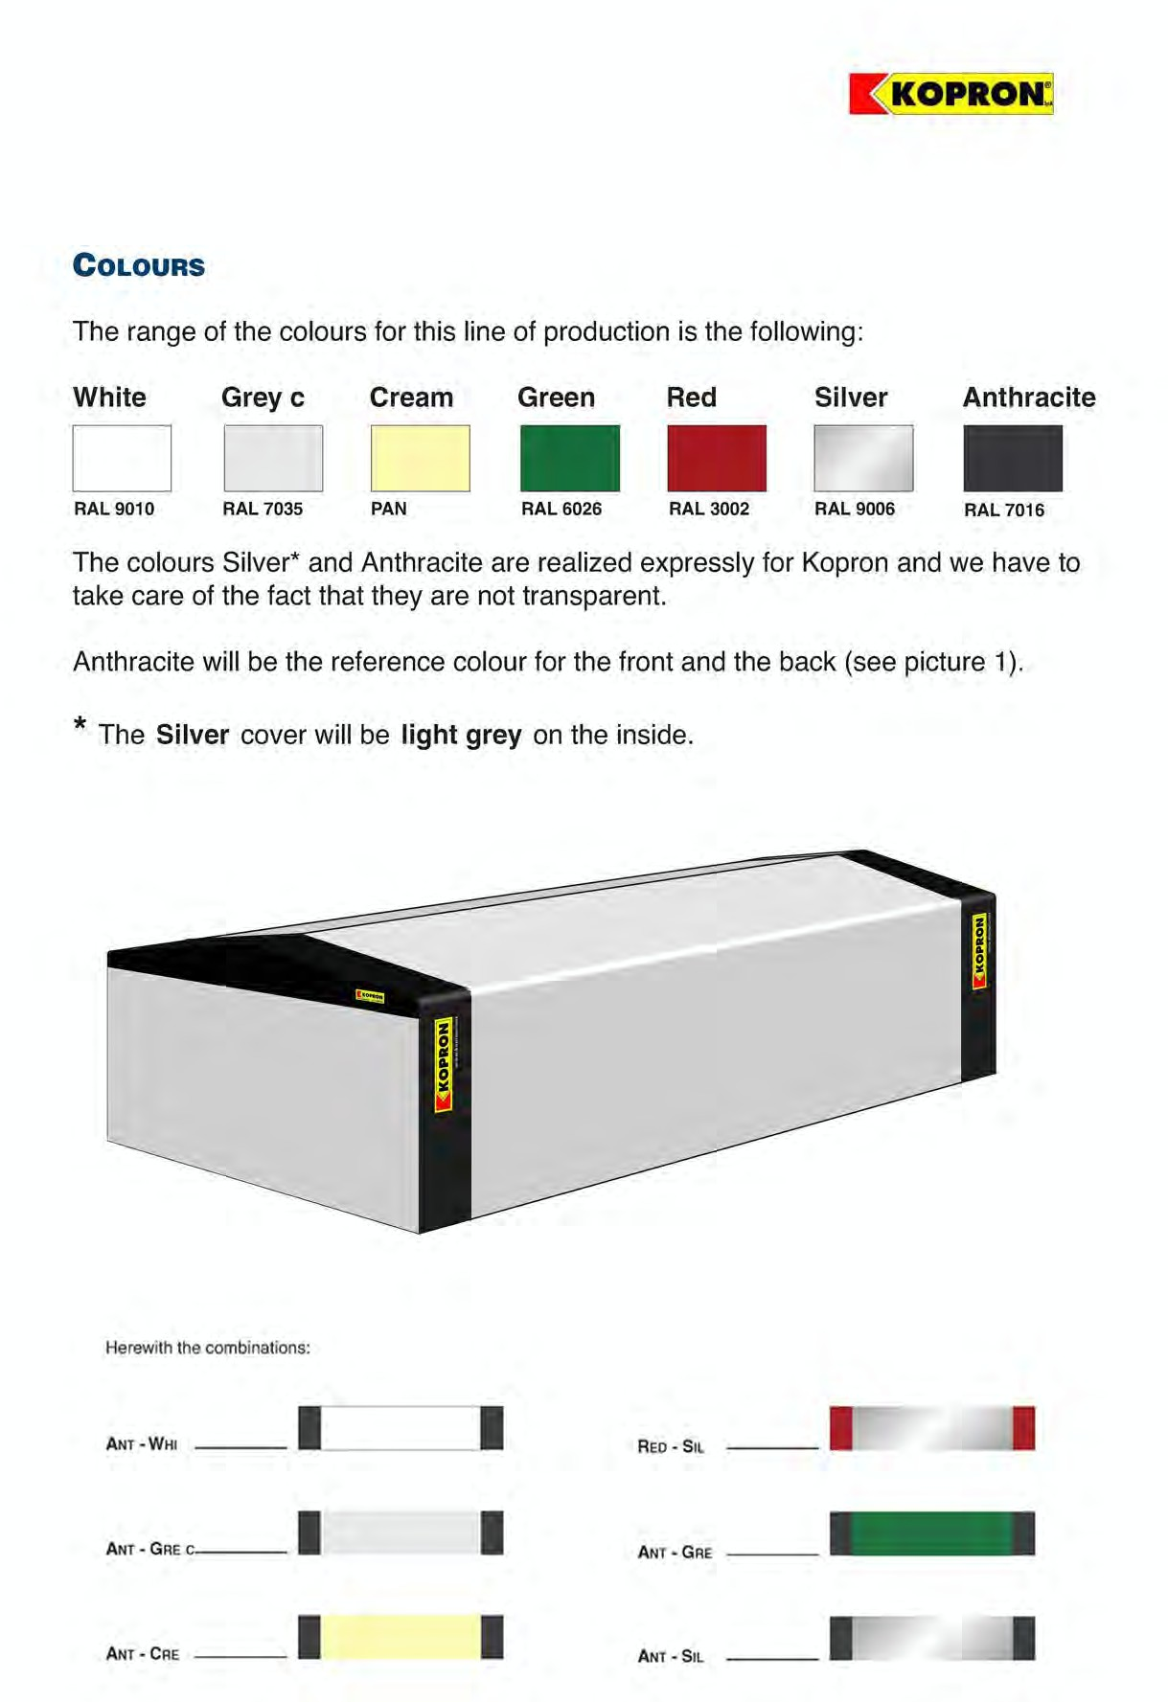

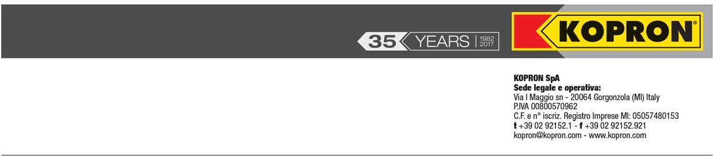

KT
FOLDING FREESTANDING PVC WAREHOUSE

DECLARATION

Hereby we declare that the steel structure in question has been manufactured according to the provisions of the regulations in force and in particular:

  - Norme tecniche per le costruzioni D.M. 14.01.2008 (technical regulations which defines the principles for the project, execution, and the final test, concerning the performances in mechanical resistance and stability, also in case of fire and durability)

Circolare esplicativa 617 02.02.2009 (Instructions for the application of the technical for the constructions dated 14.01.2008)

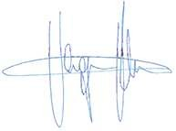Kopron Spa è un’azienda certificata ISO 9001:2008

Kopron Spa
DOC.2010.A.KV

WAREHOUSES GENERAL GUARANTEE CONDITIONS

- GUARANTEE FOR PVC FABRIC = 6 years and has value for:

  - Loss of impermeability
  - Anomalous aging
  - Insufficient self-estinguishness
  - Anomalous mildew presence
  - Defects of the product Guarantee duration:
- 1° year = 100 %
- 2° year = 90%
- 3° year = 80%
- 4° year = 70%
- 5° year = 60%
- 6° year = 50%

GUARANTEE FOR STEEL STRUCTURE

  - Defects of the product
The guarantee is subordinated to a correct maintenance and use Guarantee duration: 10 years

Whichever legal controversy will be under Italian law.

